Chapter 3(continue)

What is Du Pont Control Chart ? (With Diagram)
Read this article to learn about the Du Pont Control Chart.
The Du Pont Control Chart is called as such because Du Pont Company of the USA first used it. The various factors affecting the Return on Investment (ROI) are illustrated through this chart. ROI represents the earning power of the business.
It depends on two ratios:
(a) Net Profit ratio and
(b) Capital Turnover Ratio.
A change in any one of the two ratios will change the business earning power (i.e., ROI), and they are affected by many factors. The chart shown below exhibits that ROI is affected by a number of factors.
Any change in these factors will affect the return on capital employed. For example, if the cost of goods sold decreases without any corresponding decrease in selling price, the net profit will increase and therefore, ROI will also increase.

Similarly if there is decrease in working capital, the total capital employed will decrease and therefore, in the absence of any decrease in the net profit, ROI will decrease.
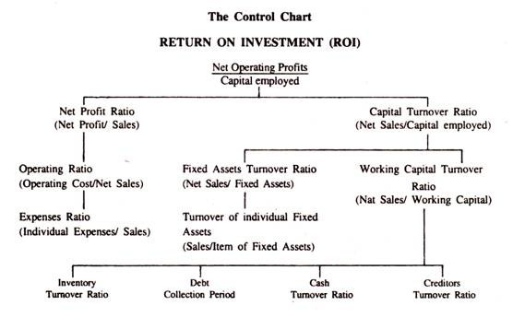
The Du Pont Chart helps management to identify the areas of problems, which affect profit, In other words, management can easily visualize the different forces affecting profits, and profits could be improved either by putting capital into effective use, which will result in higher turnover ratio, or by better sales efforts, which will result in higher profit ratio.
The same rate of return could be obtained either by a higher net profit ratio but low turnover ratio, or by a higher turnover ratio but a low net profit ratio.

Inter & Intra firm Comparison | Meaning | Definition | Need
- Meaning of Inter-Firm Comparison
Inter firm comparison means a comparison of two or more similar business units with the objective of finding the competitive position to improve the profitability and productivity of those business units. Thus, inter firm comparison is a tool used by the management of a company to compare its operating performance and financial results with those of similar companies engaged in the same industry.
- Definition of Inter-firm Comparison
According to Centre for Inter-firm Comparison, established by the British Institute of Management, Inter firm Comparison is concerned with the industrial firm, its success and the part played by the management in achieving it. The end product of a properly conducted inter firm comparison is not a statistical survey but the flash of insight in the mind of meaning director of the firm which has taken part in such an exercise. The results of this give him an instant and vivid picture of how his firm’s profitability, its costs, its stock turnover, and other key factors affecting the success of a business compares with other firms in his industry.
The way in which the results of inter firm comparisons are presented to him makes him see clearly where his firm is weaker or stronger than its competitors; what weaknesses call for his own attention, what possibilities of improving those weaknesses or reinforcing the firm’s strength he should explore; in what respects the general objectives and specific targets of the firms should be changed.
- Meaning of Intra-firm comparison
Intra-firm comparison means comparison of two or more departments or divisions of the same business unit with the objective of meaningful analysis in order to improve the operational efficiency of all the departments or divisions.
Both, the inter firm comparison and intra-firm comparison have the same objectives. The comparison may cover the financial position or operating results or both.
- Need for Inter-firm & Intra-firm comparison
The survival and growth of any business unit are based on the competitive strength. The competitive strength is based on the financial position and solvency of the company. Some ratios are calculated to find out the financial position and solvency. A business unit can get success in market by knowing the strength and weakness of other similar business units. In this situation, there is a need of inter-firm comparison. Besides, a business unit can identify the strength of its various departments and divisions before competing with other similar business units. In this context, there is a need of intra-firm comparison.
- Differences
Inter firm comparison:
It means comparing the two or more than two similar types of business units.
The objective here is to find to suitable position with regard to competition , also in order to increase profit as well as the product.
it's actually a tool for the management of a firm in order to compare the performance as well as the result
Intra firm comparison:
it is actually about the comparing of two more than two department of the same firm or the business unit.
The main objective here is to improve the efficiency and analysis the performance of departments.

Chapter 4

Fund Flow Statement

Meaning of Fund Flow Statement:
A fund flow statement is a statement in summary form that indicates changes in terms of financial position between two different balance sheet dates showing clearly the different sources from which funds are obtained and uses to which funds are put.
It summarizes the financing and investing activities of the enterprise during an accounting period.
By depicting all inflows and outflows of fund, the statement shows their net impact on working capital of the firm.
If the total of inflows is greater than the outflows, the excess goes to increase in working capital. If there is deficit of funds during a particular accounting period, the working capital is impaired. So fund flow statement is an important tool for working capital management.
Roy A. Fouke defines fund flow statement as “a statement of sources and application of funds is a technical device designed to analyse the changes in the financial condition of a business enterprise between two dates.”
Thus, the fund flow statement reveals the volume of financial transactions and explains the flow of funds taking place within a business during a particular period of time and its effect on the net working capital. It is not a substitute for either the Profit and Loss Account or the Balance Sheet, but it is an useful supplement to them.
It describes the sources from which funds are obtained and the uses of these funds, in a condensed form.

Objectives of Fund Flow Statement:
Some of the important objectives of preparing fund flow statement are:
1. Fund flow statement reveals clearly the changes in items of financial position between two different balance sheet dates showing clearly the different sources and applications of funds. Thus, it summarizes the financing and investing activities of the enterprise.
2. It also reveals how much of the total funds is being collected by disposing of fixed assets, how much from issuing shares or debentures, how much from long-term or short-term loans, and how much from normal operational activities of the business.
3. It also provides information about the specific utilisation of such funds i.e., how much has been used for acquiring fixed assets, how much for redemption of preference shares, debentures or short-term loans as well as payment of tax, dividend etc.
4. It helps the management in depicting all inflows and outflows of funds which cause a change in working capital of a business organisation.
5. The projected fund flow statement helps management to exercise budgetary control and capital expenditure control in the enterprise.
Management uses fund flow statement for judging the financial and operating performance of the business.

Importance of Fund Flow Statement:
The importance of fund flow statement may be summarised:

1. Analyses Financial Statements:
Balance Sheet and Profit and Loss Account do not reveal the changes in the financial position of an enterprise. Fund flow analysis shows the changes in the financial position between two balance sheet dates. It provides details of inflow and outflow of funds i.e., sources and application of funds during a particular period.
Hence it is a significant tool in the hands of the management for analysing the past, and for planning the future. They can infer the reasons for imbalances in the uses of funds in the past and take corrective measures for the future.

2. Answers Various Financial Questions:
Fund flow statement helps us to answers various financial questions such as:
(a) How much fund flowed into the business?
(b) How much of these funds were provided by the operations?
(c) What are the other sources of funds?
(d) How were these funds used?
(e) Why was there less/more amount of net working capital at the end of the period than at the beginning?
(f) Why were the dividends not larger?
(g) How was the purchase of fixed assets financed?
(h) Where have the net profits gone?
(i) How were the loans repaid?

3. Rational Dividend Policy:
Sometimes it may happen that a firm, instead of having sufficient profit, cannot pay dividend due to inadequate working capital. In such circumstances, fund flow statement shows the working capital position of a firm and helps the management to take policy decisions on dividend etc.

4. Proper Allocation of Resources:
Financial resources are always limited. So it is the duty of the management to make its proper use. A projected fund flow statement enables the management to take proper decision regarding allocation of limited financial resources among different projects on priority basis.

5. Guide to Future Course of Action:
The future needs of the fund for various purposes can be known well in advance from the projected fund flow statement. Accordingly, timely action may be taken to explore various avenues of fund.

6. Proper Managing of Working Capital:
It helps the management to know whether working capital has been effectively used to the maximum extent in business operations or not. It depicts the surplus or deficit in working capital than required. This helps the management to use the surplus working capital profitably or to locate the resources of additional working capital in case of scarcity.

7. Guide to Investors:
It helps the investors to know whether the funds have been used properly by the company. The lenders can make an idea regarding the creditworthiness of the company and decide whether to lend money to the company or not.

8. Evaluation of Performance:
Fund flow statement helps the management in judging the financial and operating performance of the company.

Limitations of Fund Flow Statement:
Despite its various advantages, the fund flow statement suffers from certain limitations:

1. Historical Nature:
The information used for the preparation of the fund flow statement is essentially historical in nature. It does not estimate the sources and application of funds for the near future.

2. Structural Changes Not Disclosed:
The fund flow statement does not disclose the structural changes in financial relationship in a firm. In other words, it does not reveal shifts among items making up the current assets and current liabilities. It does not tell us whether any loss of working capital has unduly weakened the financial position or not.

3. Not Foolproof:
The fund flow statement is prepared from the data provided in the balance sheet and profit and loss account. Hence, the defects in financial statements

4. Ignores Non-Fund Items:
As fund flow statement ignores non-fund items, it becomes a crude device compared to income statement and balance sheet.

5. Not Relevant:
A study of changes in cash (i.e., cash flow statement) is more relevant than a study of changes in funds for the purpose of managerial decision-making.

General Rules:
We know, working capital (WC) = Current Assets (CA) – Current Liabilities (CL) or, WC = CA – CL
From the above equation, we may deduce
(i) An increase in CA or a decrease in CL – Causes an increase in WC
(ii) A decrease in CA or an increase in CL – Causes a decrease in WC
(iii) A simultaneous increase in CA and CL or a simultaneous decrease in CA and CL— will have no effect on WC.
A flow of funds takes place only if a transaction involves one current account (CA or CL) and one Non-current account (NCA or NCL).
From above the following general rules can be formed:
(i) Transactions which involve only current accounts (CA or CL) do not result in a flow of funds.
(ii) Transactions which involve only Non-current accounts (NCA or NCL) do not result in a flow of funds.
(iii) Transactions which involve one current account (CA or CL) and one Non-current account (NCA or NCL) results in a flow of funds.

Preparation of Fund Flow Statement:
Generally, two comparative balance sheets—one at the beginning and the other at the end of the period—are used for preparing a fund flow statement. In addition, a summarised income statement comprising non-fund or ‘non-operating’ items and a statement of retained earnings or at least material information from these statements are required in order to find out fund from operations.
Additional information regarding change in non-current accounts like plant and machinery, building, share capital, debentures etc., if available, will sharpen the firms financial profile as revealed by the fund flow statement.
The fund flow analysis involves the preparation of two statements:
(a) Statement or Schedule of Changes in Working Capital and
(b) Statement of Sources and Application of funds.

1. Statement or Schedule of Changes in Working Capital:
The primary purpose of a fund flow statement is to explain the net change in working capital, it will be better to prepare first the schedule of changes in working capital before preparing a fund flow statement.
The Schedule or Statement of changes in working capital is a statement that compares the change in the amount of current assets and current liabilities on two balance sheet dates and highlights its impact on working capital.
The format of this statement is:
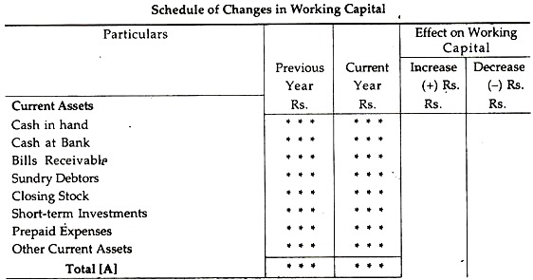
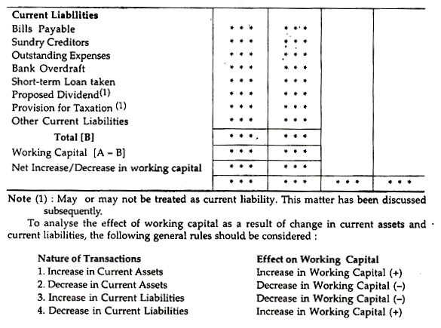

2. Fund Flow Statement:
After preparing the schedule of changes in working capital, the next step is to prepare the Fund Flow Statement to find out the different sources and applications of funds. While preparing this statement the emphasis is given on the changes in the fixed assets and fixed liabilities. The statement may be prepared either in ‘T form’ or in ‘Vertical form’.

A proforma of each of them is given:
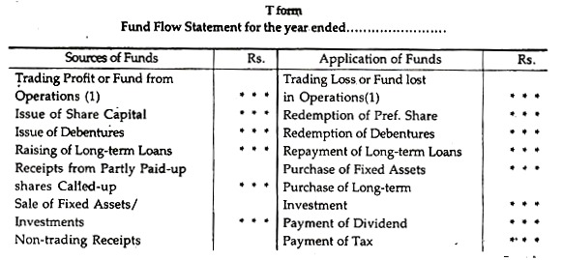
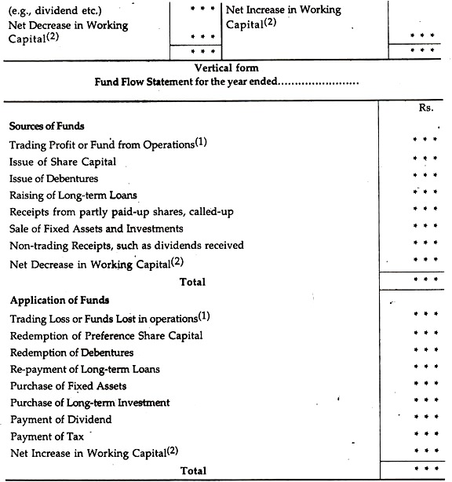
Notes:
(1) Either of the two will appear in the Fund Flow Statement.
(2) Either of the two will appear in the Fund Flow Statement.
(3) Payment of dividend and tax will appear as an application of funds only when these items are appropriation of profits and not current liabilities.

